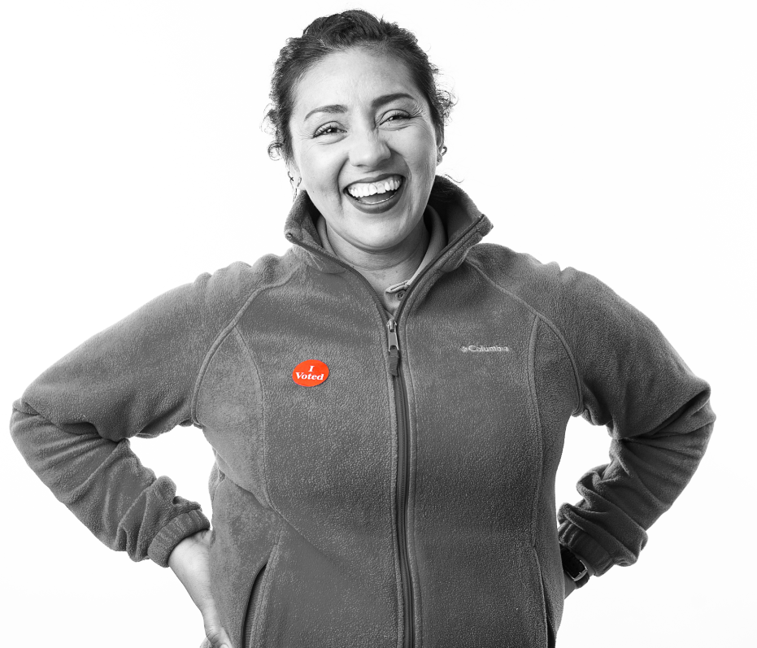

 | 2022 Basic Election Judge Training  Activity Packet – City of Corcoran

Hennepin County Elections, Election Judge Training Workgroup
Revised 6/07/2022
Version 1.1

Sections
Opening the polls 2
General rules & procedures 4
Greeter Judge 5
Poll Book Judge (Checking in registered voters) 6
Poll Book Judge (Registering voters) 8
Challenges 10
Demonstration Judge 11
Ballot Judge 12
Ballot Counter Judge 13
Closing the polls 14

Opening the polls
- When setting up the polling place room/area, which of the following factors need to be considered:
  - Traffic flow
  - Voter privacy
  - Access
  - All of the above
- TRUE or FALSE?
All judges must take the oath and sign the Official Precinct Certification Form, regardless of what shift they are working.
- TRUE or FALSE?
You need to mark a test ballot with the OmniBallot in the morning.

- If the “Public Count” on the ballot counter is any number other than 0 when you turn it on in the morning, you should:
  - Proceed as normal
  - Put that number of ballots in the ballot box
  - Contact Election Headquarters immediately for guidance
  - Postpone the opening of the polling place
- TRUE or FALSE?
When comparing the ballot and the Zero Tape, the offices and candidates must match in both order and in spelling.

- TRUE or FALSE?
After the Zero Tape prints when you are opening the polls on the ballot counter, you should tear it off.

- When you open the polls at 7 am, what should be in the ballot box?
  - Unopened packs of ballots
  - Extra Election Day supplies
  - OmniBallot test ballots
  - Nothing

- TRUE or FALSE?
If you finish polling place setup before 7 am, you should open the polls early

- TRUE or FALSE?
You can open the polls later than 7 am if you are having technological difficulties or if there are no voters waiting in line outside the polling place

- Once you have been assigned your role in the polling place, you should:
  - Review the corresponding duty card or section in the Election Judge Guide as time permits
  - Make sure you have all the supplies you need
  - Ask any questions you may have about the duties and responsibilities
  - All of the above

- How many sample ballots must be posted near the entrance to the voting room?
  - None
  - One
  - Two – each at a different height
  - As many as deemed appropriate

General rules & procedures
- TRUE or FALSE?
A voter can wear campaign materials tied to a party, candidate, or issue/question that is NOT on the ballot.
  - True
  - False

- Party balance is required for all of the following polling place tasks except:
  - Curbside voting
  - Initialing unmarked ballots
  - Duplicating ballots
  - Emptying the ballot box
  - Helping a voter to mark their ballot

- When are news media permitted in the polling place?
  - Between the hours of 9 am and 3 pm
  - Any time during polling place hours, as long as they have a written letter of permission from election officials
  - Any time during polling place hours, as long as they present their media ID and credentials to the Head Judge
  - Only when there are no voters in the polling place

- TRUE or FALSE?
Election judges should have political discussions in the polling place.

- TRUE or FALSE?
Exit polling may be conducted inside the room where the polling place is located.

- Which of the following devices may election judges use while working in the polling place?
  - Cell phone
  - Laptop
  - e-Reader
  - None of the above

Greeter Judge
- As the Greeter Judge, you should (select all that apply):
  - Maintain traffic flow
  - Verify that voters are in the correct precinct
  - Answer questions from non-registered voters regarding Election Day registration requirements
  - Make sure that all required signage is posted

- The Greeter’s List contains
  - Suggested greetings for voters who enter the polling place
  - The name and address of every registered voter in the precinct
  - The address of every polling place in the city
  - Descriptions of each of the Greeter Judge’s duties

- TRUE or FALSE?
If a voter is not in the Greeter’s List, you should use the Precinct Finder to verify that they are at the correct precinct/polling place.

- TRUE or FALSE?
If any voters enter the polling place wearing prohibited campaign materials, you should ask them to remove said materials or turn them inside out.

Poll Book Judge (Checking in registered voters)
- TRUE or FALSE?
A voter must provide election judges with their MN Driver’s License or State ID to scan into the poll book as part of the check-in process.

- How much of a voter’s first and last name should you search for in the poll book?
  - 3 letters
  - 4 letters
  - 5 letters
  - Type their entire first and last name

- The rosters on your poll books will include the voters registered in:
  - The county
  - Your city
  - Your precinct
  - The state

- TRUE or FALSE?
If you are unsure how to spell a voter’s name, you should ask them for clarification on spelling so that you know what search terms to enter.

- Examples of poll book notations include:
  - Challenged
  - AB
  - Unregistered
  - Both A and B

- If you are having difficulty finding a voter on the poll book just by searching for their first and last name, you should try searching by:
  - Their date of birth
  - Middle name only
  - Address
  - Both A and C

- Which of the following are reasons to fill out the Roster Correction Form? (Select all that apply.)
  - Name misspelled
  - The voter moved, but within the same precinct
  - Date of birth incorrect
  - Date of birth missing
  - All of the Above

- TRUE or FALSE?
At the Voter Confirmation screen, you should turn the poll book towards the voter and ask them to review and confirm the information displayed.

- When you check in a registered voter, how many pieces of paper will print out on the Pollbook?
  - 1
  - 2
  - 3

- TRUE or FALSE?
Before being given the Voter’s Receipt, the voter must sign the Voter Signature Certificate.

Poll Book Judge (Registering voters)
- TRUE or FALSE?
You should manually enter street addresses when registering voters on the poll book.

- If a registered voter in the precinct moves to a new address in the precinct, or changes apartment/unit numbers at the same street address, what is the simplest proof of residence option they can use?
  - A driver’s license with the new address
  - A recent bill or statement with their name and new address on it
  - A voucher
  - Valid registration in same precinct

- TRUE or FALSE?
A receipt for a driver’s license (temporary license) can be used for both the identification and the proof of residence steps of the registration process.

- TRUE or FALSE?
For the “combo” category of proofs of residence, a voter may show one of the approved documents (e.g. a bill, account statement, or start of service statement) on an electronic device such as a tablet or phone.

- Which of the following would not be acceptable documentation to register?
  - Receipt for a driver’s license (Temporary License)
  - Driver’s license w/ previous address and a current bank statement
  - State ID and a lease agreement
  - Store charge card and a property tax statement
- TRUE or FALSE?
If a voter was vouched for in order to register on Election Day, they can then vouch for someone else.

- When you scan a driver’s license being presented, the poll book will auto-populate the:
  - Name and date of birth
  - Name and address
  - Name, date of birth, and ID number
  - ID number only

- TRUE or FALSE?
At the Voter Confirmation screen, you should turn the poll book towards the voter and ask them to review and confirm the information displayed.

- When you register a new voter or update the registration of a voter, how many pieces of paper will print out on the Pollbook?
  - 1
  - 2
  - 3

- TRUE or FALSE?
Before being issued the Voter’s Receipt, the voter must sign both the Voter Registration Application (Election Day Registration Application) and the Voter Signature Certificate.

Challenges
- Who can challenge the eligibility of a voter to vote in the precinct?
  - A candidate in the election
  - Only the City Clerk
  - An authorized challenger, election judge, or voter in that precinct
  - None of the above

- TRUE or FALSE?
If a voter you are processing has a challenge notation on their record, you should notify the Head Judge and proceed to ask the questions displayed on the poll book screen.
- If a voter’s answers to the questions regarding their challenge indicate they are eligible to vote, you should select:
  - Clear Challenge
  - Challenge Refused
  - Challenge Failed

- If a voter’s answers to the questions regarding their challenge indicate they are not eligible to vote, you should select:
  - Clear Challenge
  - Challenge Refused
  - Challenge Failed

- If a voter is not willing to take the oath and answer the questions regarding their challenge, you should select:
  - Clear Challenge
  - Challenge Refused
  - Challenge Failed

- TRUE or FALSE?
If a voter who has gone through the challenge process is marked as either “Challenge Refused” or “Challenge Failed” they can come back to the polling place later in the day to go through the process again.

Demonstration Judge
- TRUE or FALSE?
You can use an official ballot to demonstrate the ballot-marking process to a voter.

- TRUE or FALSE?
In a state primary, you should instruct voters to only vote for the candidates in one column (party) or the other.

- What is a crossover vote in a partisan primary?
  - When a voter crosses off one or more selections on their ballot
  - When a voter selects candidates of more than one party
  - When a voter for candidates of the party they generally do not agree with
  - None of the above

- TRUE or FALSE?
A voter can mark choices on their ballot by either circling a candidate's name, or making an X next to their selections.

- What is an overvote?
  - When a voter marks their candidate selection above the oval, rather than inside of it
  - When a voter casts more than one ballot
  - When a voter selects more candidates in a given race than is permitted
  - None of the above

Ballot Judge
- After opening up a sealed pack of ballots, the first thing you should do is:
  - Throw away the packaging and put the ballots in the auxiliary compartment
  - Count the number of ballots in the pack and record that number on the Ballot Tracking Form – make sure to note any discrepancies
  - Have two judges initial each ballot
  - Put the ballots in the supply box and wait until they are needed
- TRUE or FALSE?
You should notify your Head Judge when ballot supply gets low.

- TRUE or FALSE?
A voter can continue to spoil their ballot and get replacements as long as they have not yet deposited their ballot into the ballot counter.

- Which of the following are reasons for a ballot to be spoiled in a primary election:
  - An unvoted ballot abandoned at a voting booth
  - A ballot where the vote mistakenly selected candidates in both party columns
  - A ballot where the voter changed their mind and crossed out selections
  - All of the above
- TRUE or FALSE?
You can issue a ballot to a voter even if they have not presented you with a Voter’s Receipt.

Ballot Counter Judge
- TRUE or FALSE?
If a voter brings in an absentee ballot that was mailed to them, you should allow them to vote that ballot and deposit it into the ballot counter.

- When an error message appears on the ballot counter, the first thing you should do is:
  - Shut down the ballot counter
  - Read the message on the screen and explain it to the voter
  - Have other voters in line place their ballots into the auxiliary compartment
  - Give the voter a new ballot

- TRUE or FALSE?
When a voter error occurs, you must get confirmation from the voter as to which action they want to take – either cast or return the ballot. You should only proceed once you have that confirmation

- If the ballot counter stops working because of a ballot jam or system error, what should you do until the problem is resolved?
  - Have voters go home and come back later
  - Have voters put their ballots in the auxiliary compartment
  - Open the ballot box and have voters place their ballots inside
  - None of the above

- TRUE or FALSE?
You should stand close enough to the ballot counter that you can see when an error message appears, but not so close that you can see voter’s ballots as they are cast.

- TRUE or FALSE?
If a voter leaves the polling place with their ballot, they can come back later to cast it.

Closing the polls
- TRUE or FALSE?
A voter who is at their correct polling place may be permitted to vote as long as they are in line by 8 pm.

- At the end the night, unvoted ballots should be:
  - Sealed in a transfer case and brought back to City Hall
  - Put in the supply box
  - Secured in the ballot box
  - Recycled
- At the end of the night, voted ballots should be:
  - Sealed in Ballot Transfer Case and brought back to City Hall
  - Put in the supply box
  - Secured in the ballot box
  - Recycled
- TRUE or FALSE?
If you are having difficulty transmitting results, you should try moving the ballot counter to a place in the building that has a stronger signal and/or lift the antenna.

